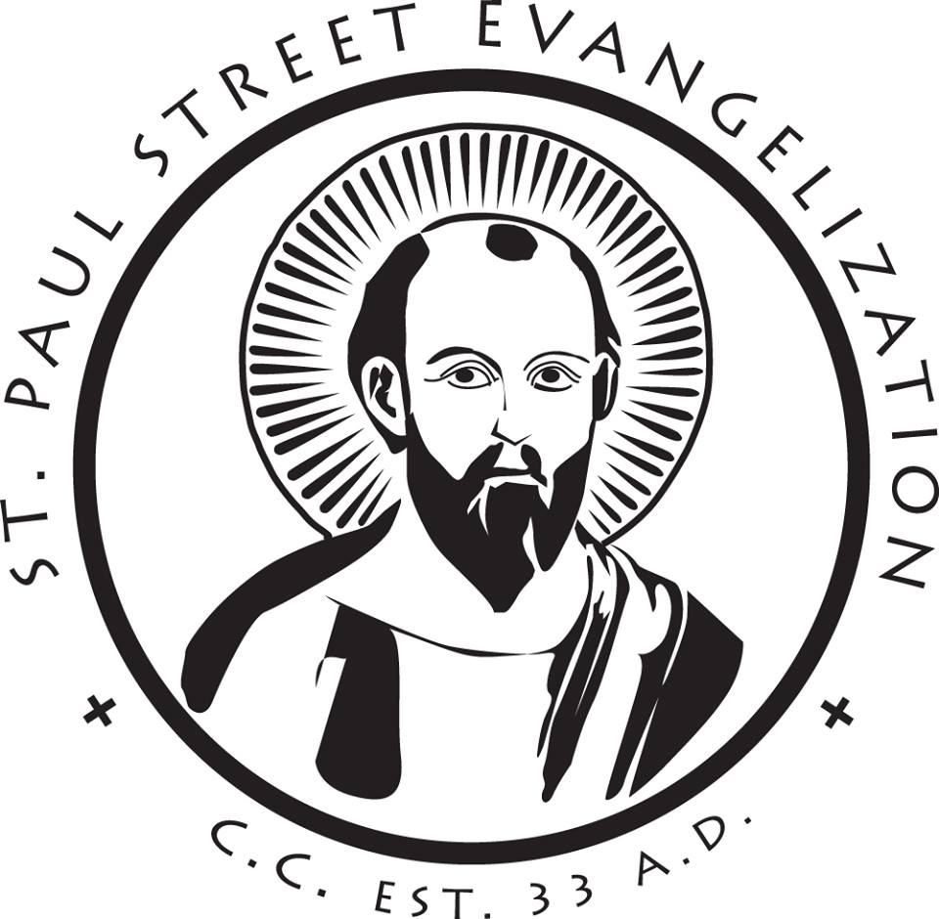
Sharing the “Good News”
Basic Evangelization Training
________________________________

Saturday, June 10th • 9:00 am – 3:00 pm
Saint John the Evangelist Parish, Rochester

Group Registration Form
[Individuals can register online at the diocesan web site: www.dow.org.]

Parish Name & Town/City…

___________________________________________________________________________

______________________________________________
- Registrant Name ___________________________________________________________
Email Address _____________________________________________________________
- Registrant Name ___________________________________________________________
Email Address _____________________________________________________________
- Registrant Name ___________________________________________________________
Email Address _____________________________________________________________
- Registrant Name ___________________________________________________________
Email Address _____________________________________________________________
- Registrant Name ___________________________________________________________
Email Address _____________________________________________________________
- Registrant Name ___________________________________________________________
Email Address _____________________________________________________________

- Registrant Name ___________________________________________________________
Email Address _____________________________________________________________
- Registrant Name ___________________________________________________________
Email Address _____________________________________________________________
- Registrant Name ___________________________________________________________
Email Address _____________________________________________________________
- Registrant Name ________________________________________________________
Email Address ___________________________________________________________
______________________________________________
Special Needs…
___________________________________________________________________________

___________________________________________________________________________

___________________________________________________________________________

___________________________________________________________________________
______________________________________________

Registration Fee…
$25.00 per person, payable to the “Diocese of Winona”
(No charge for members of the clergy)

Send Registration Form and Payment To…
Todd Graff • Office of Lay Formation • P.O. Box 588 • Winona, MN 55987-0588
(Or scan this completed form, and send via email to: tgraff@dow.org. Payment can then be mailed in, or provided on the day of the training.)

Registration Deadline…
Monday, June 5th
(Preregistration is required to participate in the training.)

For More Information, Contact…
- Todd Graff (Director of Lay Formation, Diocese of Winona)
Phone: 507-858-1270 / Email: tgraff@dow.org
- Deb McManimon (Regional Missionary, St. Paul Street Evangelization)
Phone: 507-271-1737 / Email: dmcmanimon72@gmail.com

